**Phase:4 AI Based diabetes prediction system**

**Introduction:**

Diabetes is a chronic medical condition that affects millions of people worldwide. It is characterized by elevated blood sugar levels, which can lead to a variety of health complications if not properly managed. Early diagnosis and management of diabetes are essential to mitigate these risks. Artificial Intelligence (AI) has emerged as a promising tool in the field of healthcare, including the prediction and management of diabetes. AI-based diabetes prediction systems leverage advanced algorithms and machine learning techniques to assist in the early detection of diabetes, potentially improving patient out Logistic Regression: A good starting point for binary classification problems, like predicting diabetes.

**Machine learning algorithm:**

Choosing the right machine learning algorithm for an AI-based diabetes prediction system depends on your dataset, the problem you're trying to solve, and your specific requirements. Common algorithms for medical prediction tasks.

**Step1:** Logistic Regression: A good starting point for binary classification problems, like predicting diabetes.

**Step2:** Random Forest: Effective for handling complex datasets with a mix of feature types.

**Step3**: Support Vector Machine (SVM): Useful for finding a clear boundary between classes.

**Step4**: Neural Networks: Deep learning models can capture intricate patterns but may require more data and computational resources.

**Step5:** Naive Bayes: Suitable for smaller datasets and when you want to model probabilistic relationships.

**Step6:** Decision Trees: Simple to interpret and suitable for smaller datasets.

**Step7:** Gradient Boosting: Often used for improving predictive performance.

To make an informed choice, consider the size of your dataset, the quality and relevance of your features, and the desired trade-off between model accuracy and interpretability. You may need to experiment with different algorithms and hyperparameters to find the best fit for your diabetes prediction system. Additionally, consult with domain experts to ensure the medical relevance of your approach and address ethical considerations regarding patient data and privacy.

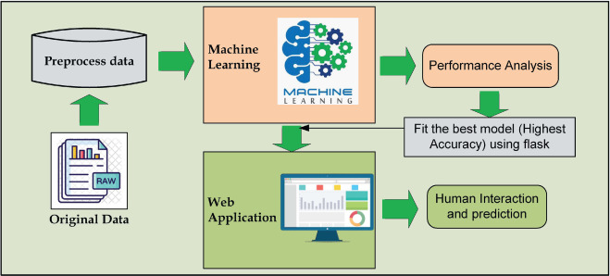

**Dataset link:**[**https://survey.zohopublic.in/zs/wNDwxo**](https://zc1.maillist-manage.in/click/11feeefb04d1196e/11feeefb04cfbfd7)

**Program:**

import numpy as np

import pandas as pd

from sklearn.model_selection import train_test_split

from sklearn import svm

from sklearn.metrics import accuracy_score

import pickle

diabetes_dataset = pd.read_csv('/content/diabetes.csv')

diabetes_dataset.head()

**output:**

|  |  |  |  |  |  |  |  |  |  |  |  |  |  |  |  |  |  |  |  |  |  |  |  |  |  |  |  |  |  |  |  |  |  |  |  |  |  |  |  |  |  |  |  |  |  |  |  |  |  |  |  |  |  |  |  |  |  |  |  |  |
| --- | --- | --- | --- | --- | --- | --- | --- | --- | --- | --- | --- | --- | --- | --- | --- | --- | --- | --- | --- | --- | --- | --- | --- | --- | --- | --- | --- | --- | --- | --- | --- | --- | --- | --- | --- | --- | --- | --- | --- | --- | --- | --- | --- | --- | --- | --- | --- | --- | --- | --- | --- | --- | --- | --- | --- | --- | --- | --- | --- | --- |
| |  | **Pregnancies** | **Glucose** | **BloodPressure** | **SkinThickness** | **Insulin** | **BMI** | **DiabetesPedigreeFunction** | **Age** | **Outcome** | | --- | --- | --- | --- | --- | --- | --- | --- | --- | --- | | **0** | 6 | 148 | 72 | 35 | 0 | 33.6 | 0.627 | 50 | 1 | | **1** | 1 | 85 | 66 | 29 | 0 | 26.6 | 0.351 | 31 | 0 | | **2** | 8 | 183 | 64 | 0 | 0 | 23.3 | 0.672 | 32 | 1 | | **3** | 1 | 89 | 66 | 23 | 94 | 28.1 | 0.167 | 21 | 0 | | **4** | 0 | 137 | 40 | 35 | 168 | 43.1 | 2.288 | 33 | 1 | |

diabetes_dataset['Outcome'].value_counts()

**output:**

0 500

1 268

Name: Outcome, dtype: int64

X_train, X_test, Y_train, Y_test = train_test_split(X,Y, test_size = 0.2, stratify=Y, random_state=2)

print(X.shape, X_train.shape, X_test.shape)

**output:**

(768, 8) (614, 8) (154, 8)

classifier = svm.SVC(kernel='linear')

classifier.fit(X_train, Y_train)

**output:**

|  |
| --- |
| SVC  SVC(kernel='linear') |

input_data = (5,166,72,19,175,25.8,0.587,51)

input_data_as_numpy_array = np.asarray(input_data)

input_data_reshaped = input_data_as_numpy_array.reshape(1,-1)

prediction = classifier.predict(input_data_reshaped)

print(prediction)

if (prediction[0] == 0):

print('The person is not diabetic')

else:

print('The person is diabetic')

**output:**

[1]

The person is diabetic

/usr/local/lib/python3.10/dist-packages/sklearn/base.py:439: UserWarning: X does not have valid feature

names, but SVC was fitted with feature names warnings.warn(

**Conclusion:**

In conclusion, AI has the potential to transform the management of diabetes by enabling early detection, personalized treatment, and improved patient engagement. It also plays a crucial role in accelerating research and drug discovery. However, it's important to address privacy and security concerns, ensure data accuracy, and involve healthcare professionals in AI-assisted decision-making to maximize the benefits of AI in diabetes care.